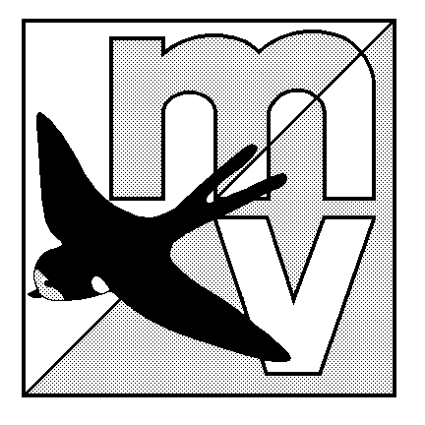MOLE VALLEY ORIENTEERING CLUB
(affiliated to British Orienteering)

TRY ORIENTEERING EVENT

The Nower, Dorking
Sunday 27th May 2012

(being run in conjunction with the 35th Surrey Hill Races – see www.sloweb.org.uk for details)

Venue: Small but interesting area of mostly runnable woodland, with many paths. All facilities are close together, and there is an ideal grassy area to have a picnic on after your run (weather permitting!)

Car Park: The Priory School, Dorking, Surrey. OS Map 187, at Grid Ref TQ158488. Follow the ‘Hill Race’ signs from South end of Dorking one-way system. Parking will be tight - please share transport where possible.

Map: 1:5000, 5m contours - maps are overprinted but not bagged.

Registration: 10.00am - 12.00pm Entry on the day only.

Starts: 10.30am - 12.30pm Courses close 2.30pm

Courses: Courses suitable for newcomers and experienced orienteers
White (1.2km), Yellow (2.2km), Orange (2.6km) and Green (4.4km)
The event will be using SportIdent electronic punching (hire charge £1).

Fees: Seniors £5.00 Juniors £2.00

Facilities: Squash, toilets. Dogs welcome except in school buildings.

Officials: Co-ordinator – Mike Elliot
Planner - Simon Ling

MV Website: http://www.mvoc.org/

Safety: Whistles recommended.

IN THE INTEREST OF SAFETY ALL COMPETITORS MUST REPORT TO DOWNLOAD
Competitors participate in this event at their own risk

